stmarys2



**St Mary's Anglican Girls' School**

**Semester Two, 2010**

**Question/Answer Booklet**

**MATHEMATICS**

**Year 12 3C/3D**

**Section One:**

**Calculator-free**

**Time allowed for this section**

Reading time before commencing work: 5 minutes

Working time for this section: 50 minutes

**Material required/recommended for this section**

***To be provided by the supervisor***

This Question/Answer Booklet

Formula Sheet

***To be provided by the candidate***

Standard items: pens, pencils, pencil sharpener, eraser, correction fluid, ruler, highlighters

Special items: nil

**Important note to candidates**

No other items may be used in this section of the examination. It is **your** responsibility to ensure that you do not have any unauthorised notes or other items of a non-personal nature in the examination room. If you have any unauthorised material with you, hand it to the supervisor **before** reading any further.

**Structure of this paper**

|  |  |  |  |  |
| --- | --- | --- | --- | --- |
| Section | Number of questions available | Number of questions to be answered | Working time (minutes) | Marks available |
| **Section One:**  **Calculator-free** | **8** | **8** | **50** | **40** |
| Section Two:  Calculator-assumed | 13 | 13 | 100 | 80 |
|  |  |  |  | 120 |

**Instructions to candidates**

1. Write your answers in the spaces provided in this Question/Answer Booklet. Spare pages are included at the end of this booklet. They can be used for planning your responses and/or as additional space if required to continue an answer.

* + Planning: If you use the spare pages for planning, indicate this clearly at the top of the page.
  + Continuing an answer: If you need to use the space to continue an answer, indicate in the original answer space where the answer is continued, i.e. give the page number. Fill in the number of the question(s) that you are continuing to answer at the top of the page.

2. **Show all your working clearly.** Your working should be in sufficient detail to allow your answers to be checked readily and for marks to be awarded for reasoning. Incorrect answers given without supporting reasoning cannot be allocated any marks. For any question or part question worth more than two marks, valid working or justification is required to receive full marks. If you repeat an answer to any question, ensure that you cancel the answer you do not wish to have marked.

3. It is recommended that you **do not use pencil** except in diagrams.

1. [4 marks]

Find the absolute maximum and absolute minimum of the function  on   
the interval .

2. [2 marks]

Find 

3. [4 marks]

Find *a* and *b* if:



4. [5 marks]

The points $P(-4,3)$, $Q(6,3)$ and $R(-2,-1)$ all lie on the graph of .  
Find *a*, *b* and *c.*

5. [6 marks]

This is the graph of , for .



(1,e)

(2,e2)

(a) The area between the graph of *y* = *ex* and the *x*-axis from *x* = 0 to *x* = 2 is rotated   
through 360° about the *x*-axis. Find, in terms of *e*, the volume of this solid. (3)

(b) On the axes below sketch the graph of . (3)

Label 3 points accurately.



(1,e)

(2,e2)

6. [10 marks]

The functions and  are defined as  and .

(a) Evaluate  (1)

(b) Show that there are no points on the graph of *g*(*x*) where the gradient is 1. (4)

(c) To find the domain of (*f* ° *g*)(*x*), it is necessary to solve the inequality .

Explain why. (1)

(d) Find the domain of (*f* ° *g*)(*x*). (4)

7. [5 marks]

Consider the function *f* with second derivative . The graph of *f* has a minimum point at A(2,4) and a maximum point at B.

(a) Justify that B is a maximum. [2]

(b) Given that , show that . [1]

(c) Find . [2]

8. [4 marks]

Let *f* be a function defined on the interval . The graph of *f*, consisting of 4 line segments, is shown below.

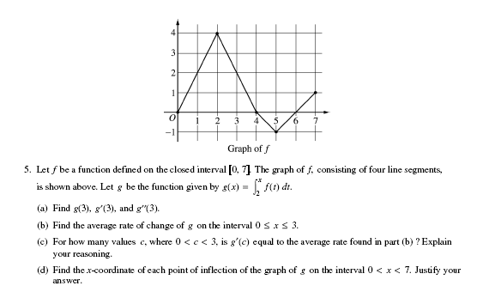

Let *g* be the function given by .

(a) Find *g*(3) and *g*(6). (2)

(b) Find . (2)

Additional working space